OFFICIAL VERSION 1.0 OCTOBER 2018
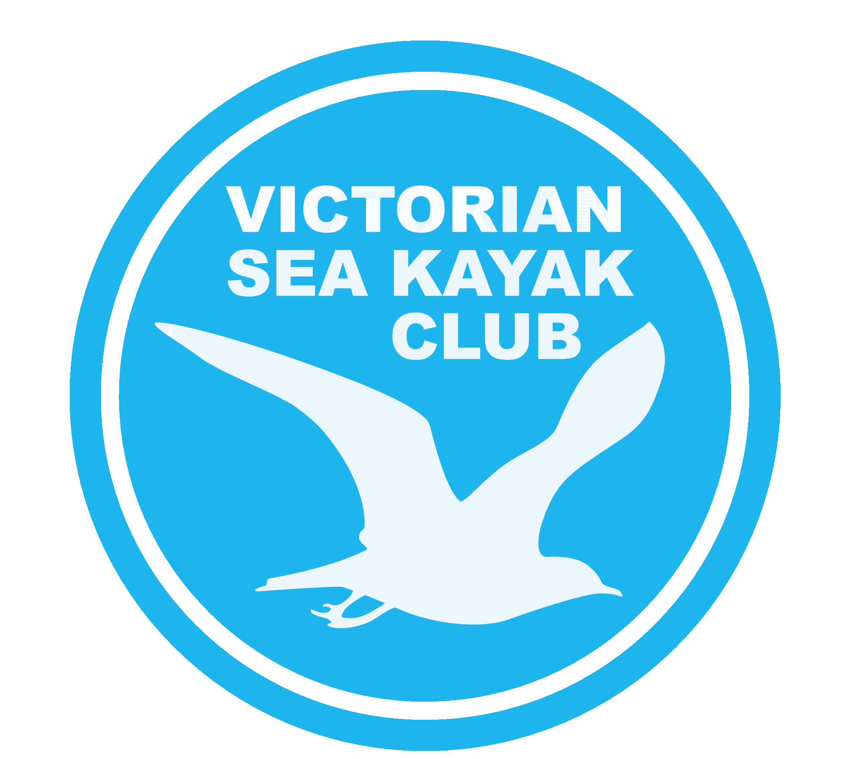

- Sea Kayak Basics
- Intro to Sea Skills
- Sea Skills
- Sea Leader
- Sea Instructor

Sea Kayak Basics
Sea Kayak Basics represents the minimum skills and knowledge required to safely participate in a VSKC paddle. Demonstration of these basic skills allows a paddler to progress from novice to beginner and join VSKC paddles on enclosed waters in conditions deemed safe by the Trip Leader.

Assessment: Can be assessed by Sea Leaders, VSKC Grade 3 Trip Leaders and Sea Instructors who meet respective currency requirements. The competencies outlined below must be demonstrated confidently on or prior to participating in a member’s first club paddle. Assessment is available on selected, regular VSKC paddles by prior agreement with the relevant Trip Leader. Where a paddler is unfamiliar with any required knowledge or skills (refer below), a Trip Leader will teach and demonstrate the knowledge and/or skill on land and/or water as appropriate prior to any assessment.

Recognition of prior learning: In order to recognise any prior learning, relevant official documentation must be provided to the Trip Leader prior to the paddle. Otherwise the paddler is required to demonstrate the knowledge and skills outlined below to the satisfaction of the Trip Leader.

Conditions: Enclosed waters, wind <10 knots and seas <1 metre.

Knowledge:
- Present sea kayak and on board equipment to VSKC standards for inspection (i.e. hatches and other equipment set or stowed ready for launch, safety equipment, on- board water supplies and communication device waterproofed and packed).
- Present themselves for the paddle suitably dressed for the conditions on the day and know how to modify paddle clothing to suit changing conditions
- Understand use of whistle, hand and paddle signals to communicate.
- Show an understanding of correct posture for paddling and basic injury prevention

Skills:
- Competently fit the spraydeck, launch the kayak and paddle away in a
controlled manner
- Paddle forward and turn the kayak in an efficient manner
- Perform a basic low brace support stroke
- Come alongside and raft up as a group or with at least one other kayak
- When signalled, perform a competent wet exit from the kayak
- Get back into the kayak with assistance from other paddlers
- Swim 50 metres in sea kayaking gear (shirt, shorts, and footwear as a minimum, wearing a spraydeck and personal flotation device)
- Demonstrate an ability to maintain an effective group paddling pace (as a guide,
5 km/hr for a period of one hour, without undue stopping).

The candidate has demonstrated all of the required competencies for Sea Kayak Basics.

Candidates Name: Date:

Assessors Name: Assessors Signature:

